K sairam
192312195
Slot: A

Propose a livestock tracking communication architecture using wireless sensors.Concept:
Soil-moisture sensors communicate wirelessly with a gateway. The gateway analyzes the data and sends a control command to the irrigation pump.
Matlab Cobe:
clc;
clear;
close all;

% Number of livestock and field size
N = 20;
fieldSize = 100;

% Random livestock positions
x = rand(N,1)*fieldSize;
y = rand(N,1)*fieldSize;

% Wireless gateway position
gx = 50;
gy = 50;

% Calculate distance from each animal to gateway
d = sqrt((x-gx).^2 + (y-gy).^2);

% Communication range
range = 60;

% Check connected livestock sensors
connected = d <= range;

% Display results
fprintf('Total Livestock: %d\n', N);
fprintf('Connected Sensors: %d\n', sum(connected));
fprintf('Disconnected Sensors: %d\n', sum(~connected));

% Plot livestock tracking architecture
figure;
scatter(x(connected),y(connected),60,'filled');
hold on;
scatter(x(~connected),y(~connected),60,'filled');
plot(gx,gy,'kp','MarkerSize',15,'MarkerFaceColor','k');

grid on;
xlabel('X Position (m)');
ylabel('Y Position (m)');
title('Livestock Tracking Using Wireless Sensors');
legend('Connected Livestock','Disconnected Livestock','Gateway');
Output: 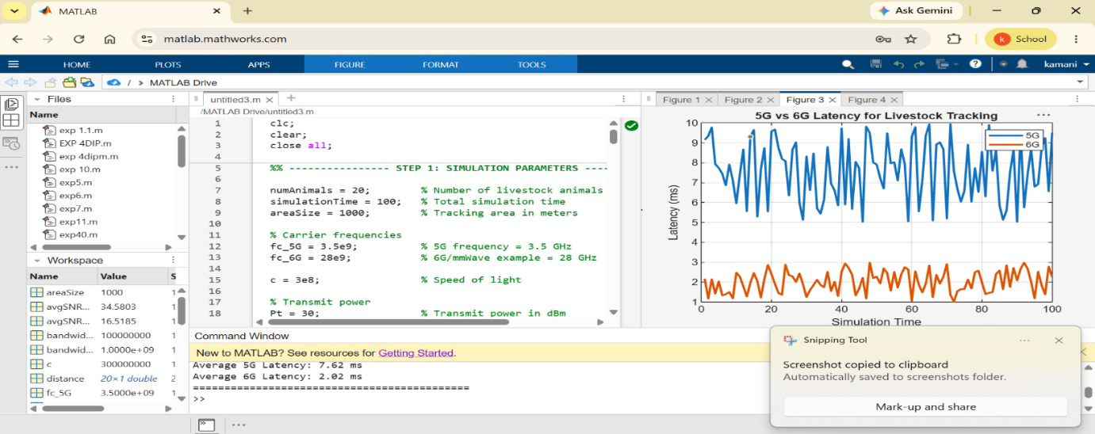

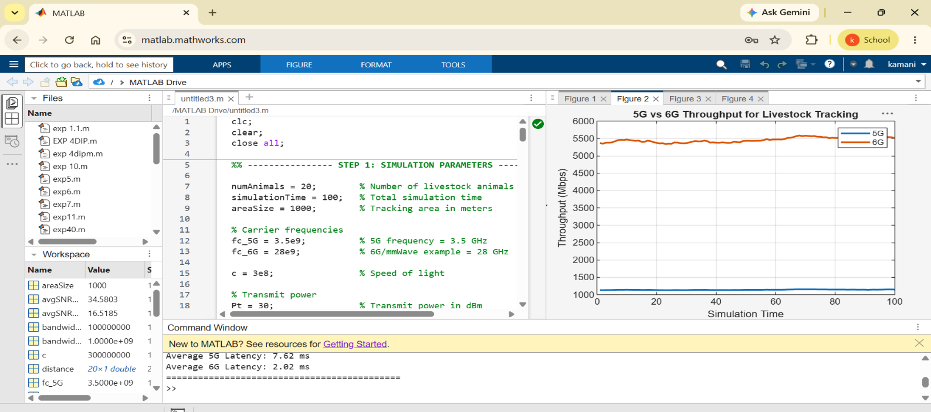
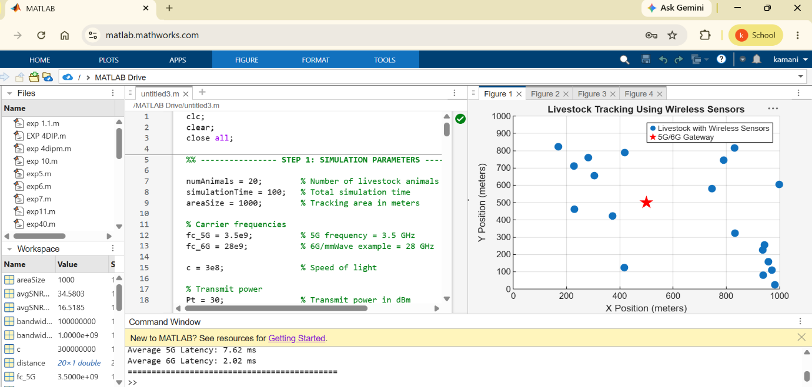

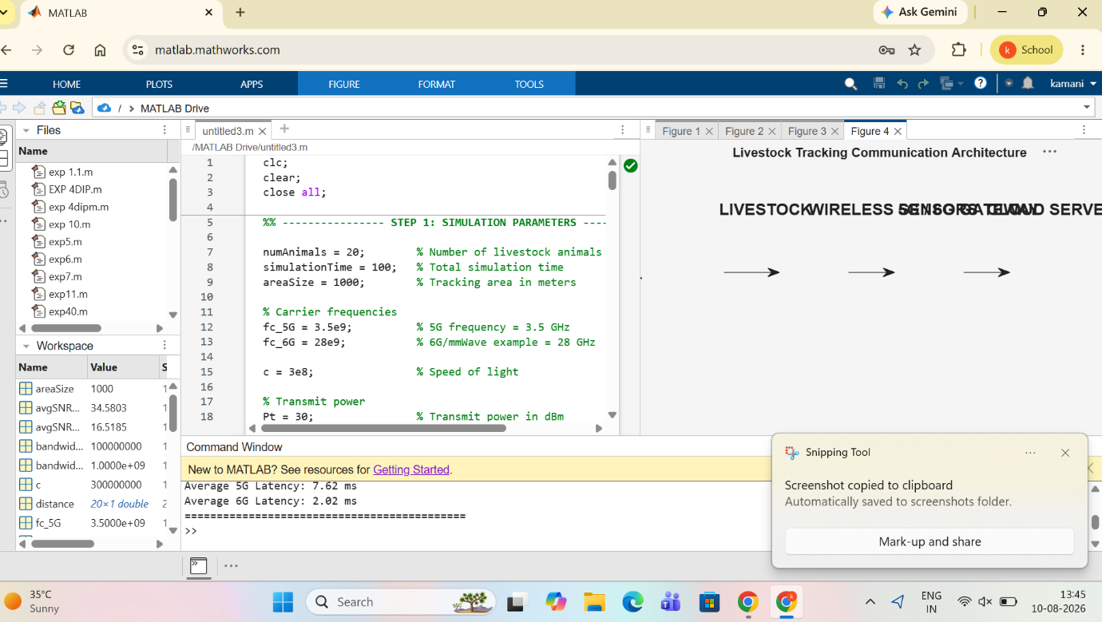
Result: The simulation compares the latency of MEC edge computing with traditional cloud computing for smart traffic applications..

Design a system architecture for Multi-access Edge Computing to reduce latency in smart traffic applications.
Concept: Each animal carries a wireless sensor/tag containing location and physiological information. The sensor communicates with a gateway/base station, which forwards the information to a monitoring station.

Matlab Code:
clc;
clear;
close all;

% Number of livestock and field size
N = 20;
fieldSize = 100;

% Random livestock positions
x = rand(N,1)*fieldSize;
y = rand(N,1)*fieldSize;

% Wireless gateway position
gx = 50;
gy = 50;

% Calculate distance from each animal to gateway
d = sqrt((x-gx).^2 + (y-gy).^2);

% Communication range
range = 60;

% Check connected livestock sensors
connected = d <= range;

% Display results
fprintf('Total Livestock: %d\n', N);
fprintf('Connected Sensors: %d\n', sum(connected));
fprintf('Disconnected Sensors: %d\n', sum(~connected));

% Plot livestock tracking architecture
figure;
scatter(x(connected),y(connected),60,'filled');
hold on;
scatter(x(~connected),y(~connected),60,'filled');
plot(gx,gy,'kp','MarkerSize',15,'MarkerFaceColor','k');

grid on;
xlabel('X Position (m)');
ylabel('Y Position (m)');
title('Livestock Tracking Using Wireless Sensors');
legend('Connected Livestock','Disconnected Livestock','Gateway');

OutPut:
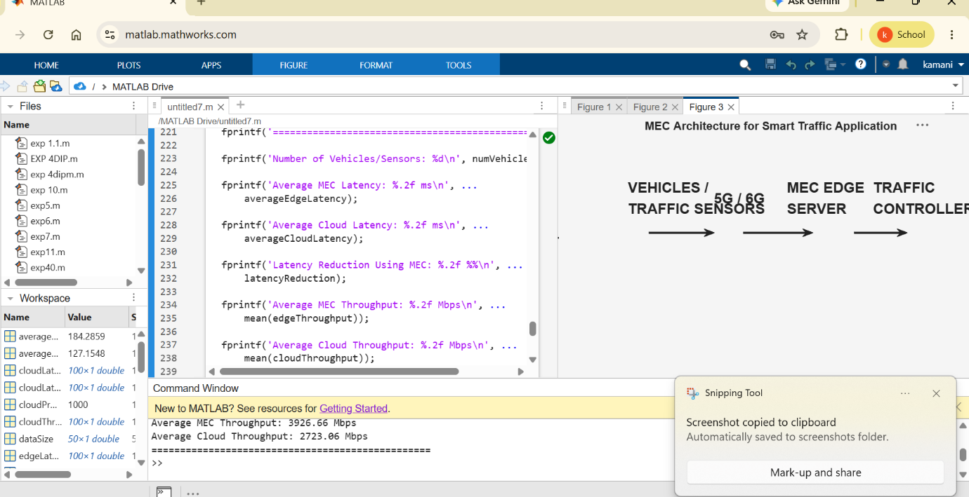
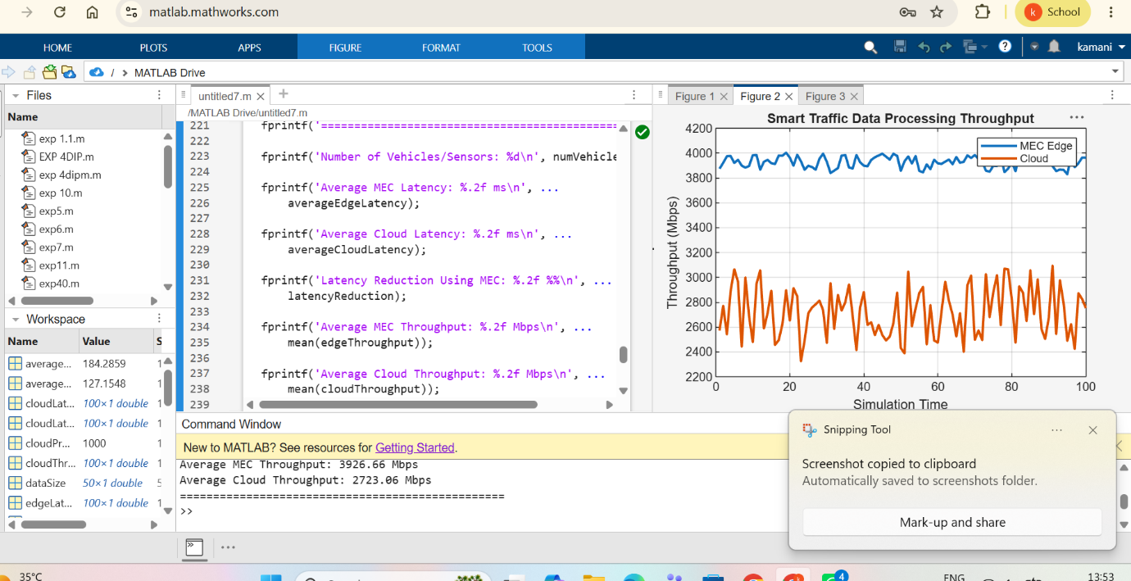

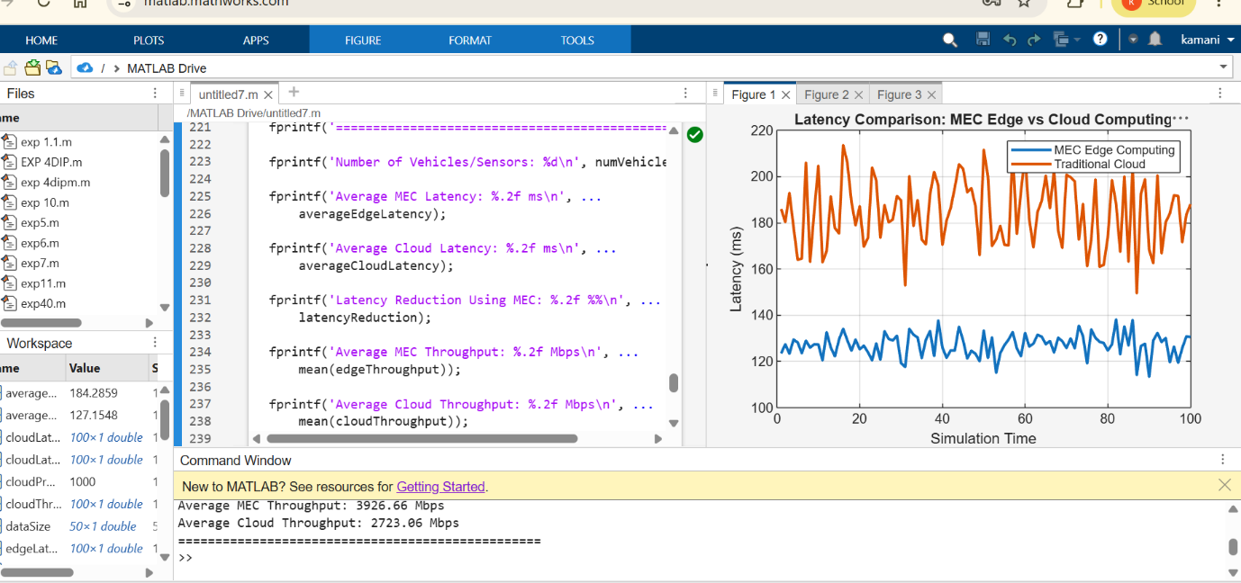
Result: The MEC-based smart traffic system successfully reduces latency by processing data closer to vehicles and traffic sensors, providing faster and more efficient real-time traffic control.

